* [The method agreement procedure](https://neuropsychology.github.io/psycho.R/2018/05/24/n_factors.html#the-method-agreement-procedure)
* [Tweaking](https://neuropsychology.github.io/psycho.R/2018/05/24/n_factors.html#tweaking)
* [Credits](https://neuropsychology.github.io/psycho.R/2018/05/24/n_factors.html#credits)

**The method agreement procedure**

When running a factor analysis, one often needs to know how many components / latent variables to retain. Fortunately, many methods exist to statistically answer this question. Unfortunately, there is no consensus on which method to use. Therefore, the n_factors() function, available in the psycho package, performs the **method agreement procedure**: it runs all the routines and returns the number of factors with the highest consensus.

library(tidyverse)

library(psycho)

results <- attitude %>%

psycho::n_factors()

print(results)

## The choice of 1 factor is supported by 5 (out of 9; 55.56%) methods (Optimal Coordinates, Acceleration Factor, Parallel Analysis, Velicer MAP, VSS Complexity 1).

We can have an overview of all values by using the summary method.

| **n.Factors** | **n.Methods** | **Eigenvalues** | **Cum.Variance** |
| --- | --- | --- | --- |
| 1 | 5 | 3.72 | 0.53 |
| 2 | 3 | 1.14 | 0.69 |
| 3 | 1 | 0.85 | 0.81 |
| 4 | 0 | 0.61 | 0.90 |
| 5 | 0 | 0.32 | 0.95 |
| 6 | 0 | 0.22 | 0.98 |
| 7 | 0 | 0.14 | 1.00 |

And, of course, plot it 

plot(results)

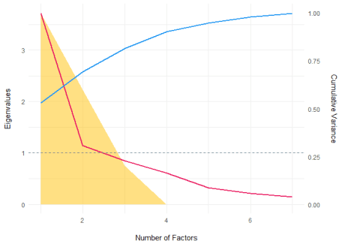

The plot shows the **number of methods** (in yellow), the **Eigenvalues** (red line) and the cumulative proportion of **explained variance** (blue line).

For more details, we can also extract the final result (the optimal number of factors) for each method:

| **Method** | **n_optimal** |
| --- | --- |
| Optimal Coordinates | 1 |
| Acceleration Factor | 1 |
| Parallel Analysis | 1 |
| Eigenvalues (Kaiser Criterion) | 2 |
| Velicer MAP | 1 |
| BIC | 2 |
| Sample Size Adjusted BIC | 3 |
| VSS Complexity 1 | 1 |
| VSS Complexity 2 | 2 |

**Tweaking**

We can also provide a correlation matrix, as well as changing the rotation and the factoring method.

df <- psycho::affective

cor_mat <- psycho::correlation(df)

cor_mat <- cor_mat$values$r

results <- cor_mat %>%

psycho::n_factors(rotate = "oblimin", fm = "mle", n=nrow(df))

print(results)

## The choice of 2 factors is supported by 5 (out of 9; 55.56%) methods (Parallel Analysis, Eigenvalues (Kaiser Criterion), BIC, Sample Size Adjusted BIC, VSS Complexity 2).

plot(results)

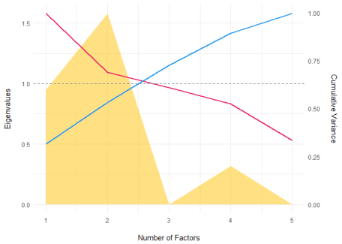

**Credits**

This package helped you? Don’t forget to cite the various packages you used 

You can cite psycho as follows:

* Makowski, (2018). *The psycho Package: an Efficient and Publishing-Oriented Workflow for Psychological Science*. Journal of Open Source Software, 3(22), 470. <https://doi.org/10.21105/joss.00470>